a)
MATCH (h:HABITATGE)<-[v:VIU]-(i:INDIVIDUAL)
WHERE h.Municipi = 'SFLL' AND NOT i.surname = 'nan' AND NOT i.surname IS NULL
RETURN h.Any_Padro as any_padro, count(i) as habitants, collect(DISTINCT i.surname) as diferent_cognoms
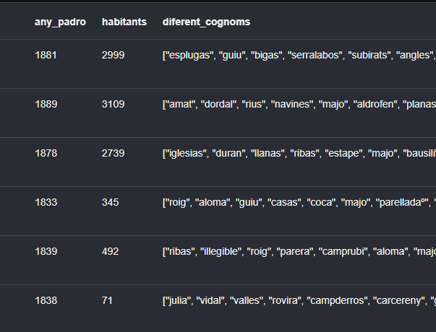

b)
MATCH (a:INDIVIDUAL)<-[s:SAME_AS]-(i:INDIVIDUAL)
WHERE (i.name = 'miguel' AND i.surname = 'estape' AND i.second_surname = 'bofill') OR (a.name = 'miguel' AND a.surname = 'estape' AND a.second_surname = 'bofill')
RETURN i.name as nom, collect(DISTINCT i.surname) as primers_cognoms, collect(DISTINCT i.second_surname) as segons_cognoms
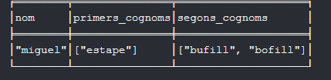

c)
MATCH (i:INDIVIDUAL)-[f:FAMILIA]->(a:INDIVIDUAL)
WHERE i.name = 'benito' AND i.surname = 'julivert' AND f.Relacio_Harmonitzada = 'fill'
RETURN a.name as nom, a.surname as cognom1, a.second_surname as cognom2, f.Relacio_Harmonitzada as relació
ORDER BY nom
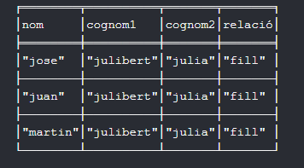

d)
MATCH (h:HABITATGE)<-[v:VIU]-(i:INDIVIDUAL)-[f:FAMILIA]->(a:INDIVIDUAL)
WHERE h.Municipi = 'CR'
WITH h, i, count(f.Relacio_Harmonitzada = 'fill') as fills
WHERE fills>3
RETURN [i.name, i.surname, i.second_surname] as cap, fills as nombre_fills
ORDER BY nombre_fills DESC
LIMIT 20
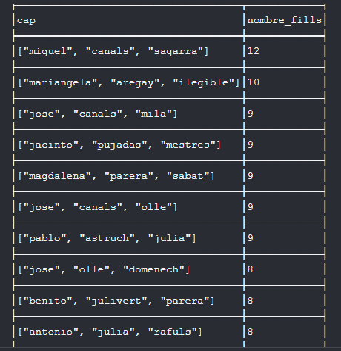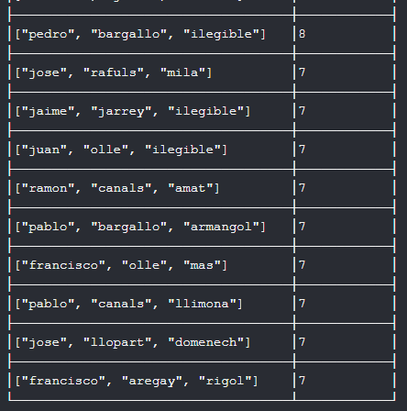

e)
Versió per ensenyar només 1 carrer:
CALL
{MATCH (h2:HABITATGE)<-[v:VIU]-(i2:INDIVIDUAL)
WHERE h2.Municipi = 'SFLL'
WITH h2,count(i2) as numH2
RETURN h2.Any_Padro as any_p, min(numH2) as n}
MATCH (h:HABITATGE)<-[v:VIU]-(i:INDIVIDUAL)
WITH h,any_p, n,count(i) as numH
WHERE h.Any_Padro = any_p AND numH = n AND h.Municipi = 'SFLL'
RETURN h.Any_Padro as any_padro, COLLECT(DISTINCT h.Carrer)[0] as carrer, numH as num
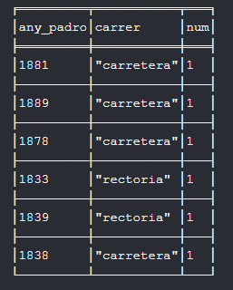

Versió per ensenyar tots els carrers amb el nombre mínim:
CALL
{MATCH (h2:HABITATGE)<-[v:VIU]-(i2:INDIVIDUAL)
WHERE h2.Municipi = 'SFLL'
WITH h2,count(i2) as numH2
RETURN h2.Any_Padro as any_p, min(numH2) as n}
MATCH (h:HABITATGE)<-[v:VIU]-(i:INDIVIDUAL)
WITH h,any_p, n,count(i) as numH
WHERE h.Any_Padro = any_p AND numH = n AND h.Municipi = 'SFLL'
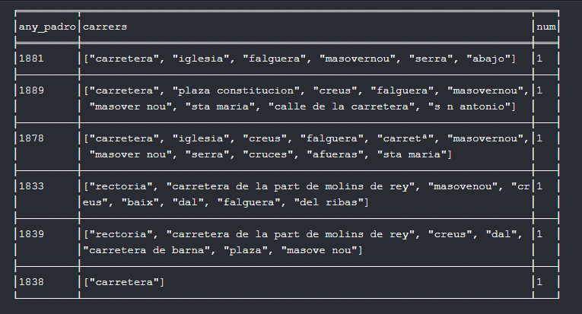
RETURN h.Any_Padro as any_padro, COLLECT(DISTINCT h.Carrer) as carrers, numH as num

